Tata Motors launches its new ‘ELANZA’ school bus, in the UAE

Receives an order for 30 buses from School Transport Services LLC

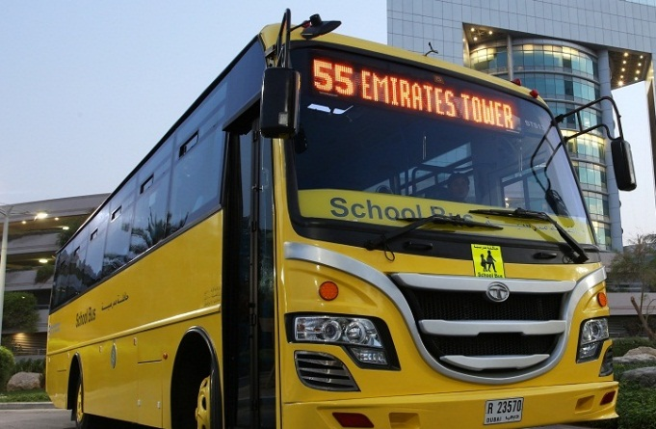
Dubai, October 06, 2015: Tata Motors, India’s largest automobile manufacturer, today announced the launch of its new next-generation school bus, in the UAE – ‘the new Tata ELANZA’. Specifically built as per stringent School Transport Regulations of the Emirates, the Tata ELANZA is built on Tata Motors MCV (Medium Commercial Vehicle) bus platform and is designed with inputs from customers across the Middle-East, setting new benchmarks in safety, comfort and operating economics.

Sporting a new elegant smiling front face with cluster projector head lamps, the new Tata ELANZA school bus is noticeable from a distance. The Tata ELANZA school bus offers easy entry and exit for 60 plus children, with a well designed step well for easy movement. Ergonomically designed seating for passengers and driver, along with rigorously tested suspension, tubeless tyres and lower NVH technologies (Noise, Vibration & Harshness) this bus provides for a comfortable journey.

With provisions for the adoption of Intelligent Transport Systems, the new ELANZA school bus from Tata Motors can be fit with optional add-ons like CCTV cameras for internal surveillance, including a child safety switch. The bus can also be hooked up to a central control room, with provisions for GPS (global positioning system), enabling real-time monitoring of the school bus, including its off-road position. These systems also allow operators to easily realign the school bus route and simultaneously update the revised route on the bus’s high quality LED destination board.

Built-in fire suppression systems, as well as a side emergency door and stop arm sign with warning lights, ensures that the Tata ELANZA meets the highest safety standards.

School Transport Services LLC, the largest private school bus operator in the UAE, confirmed an order for 30 new Tata ELANZA buses.

Mr. Rudrarup Maitra, Head of International Business, Tata Motors, “Safety of children is of paramount importance to Tata Motors, as it is to parents, who entrust their children in the hands of schools every day. The Tata Elanza school bus is no exception, with its world-class safety features, design and comfort it has to offer. We are delighted by the enthusiasm we have so far received from our customers here in the UAE, and are dedicated to enhancing the school bus service offering, backed with the trusted credentials of the Tata Motors brand.”

The unveiling of the new Elanza school bus comes as Tata Motors continues its bid to bolster its position in the school bus segment, in the UAE and the Middle-East region. The Elanza school bus will be available at the company’s Dubai Distributor-partner – United Diesel & Abu Dhabi distributor-partner, Dalma Motors.

Tata Motors is one of the world’s largest bus manufacturers, with the most complete range of transit vehicles, meeting every need arising from day-to-day travel, with a wide variety of buses and coaches – from luxurious inter-city travel options, to safe transport choices for school going children. The company continues to be a leader in the segment not just by setting technological benchmarks, but by adapting innovations effectively for safe, comfortable and economical travel. Furthermore, Tata Motors has also developed Electric Hybrid buses and Articulated buses to meet the future transport needs for ‘Envisaged Smart Cities’.

- Ends –
About Tata Motors
Tata Motors Limited is India’s largest automobile company, with consolidated revenues of INR 2,62,796 crores (USD 42.04 billion) in 2014-15. Through subsidiaries and associate companies, Tata Motors has operations in the UK, South Korea, Thailand, South Africa and Indonesia. Among them is Jaguar Land Rover, the business comprising the two iconic British brands. It also has an industrial joint venture with Fiat in India. With over 8 million Tata vehicles plying in India, Tata Motors is the country’s market leader in commercial vehicles and among the top in passenger vehicles. Tata cars, buses and trucks are being marketed in several countries in Europe, Africa, the Middle East, South Asia, South East Asia, South America, Australia, CIS and Russia.
(www.tatamotors.com ; also follow us on Twitter: https://twitter.com/TataMotors)

For further information, please contact:

Tata Motors Ltd.
Asif Shamim (Regional Manager – Middle East)
Tata Motors Limited
Email: asif.shamim@tatamotors.com
Phone: +971-42045208 / +971-567046163

Tata Motors PR Team (Dubai)
Weber Shandwick – Millie Roberts
E-mail: MRoberts@webershandwick.com
Phone: +971 4 445 4222

